Zadanie 1.

Wywołanie «execve» częściowo zastępuje obraz procesu(ang.process image). Na podstawie podręcznika execve(2)wyjaśnij, które zasoby są dziedziczone przez świeżo załadowany program. Co dzieje się z otwartymi plikami i obsługą sygnałów? Następnie znajdź w katalogu «/bin» lub «/usr/bin» pliki wykonywalne z ustawionym bitem uprawnień«set-uid» lub «set-gid». Do czego służą te bity?

Obraz procesu - is an image of a process taken when memory is allocated to it before execution. This happens because, when multitasking, the kernel needs to re-enter the process where it left off. If the process were to be changed in mid execution, bad things could happen so the operating system makes a read-only version of the process and uses that during execution.

Bit uprawnień «set-uid» lub «set-gid». Do czego służą te bity? - bit oznaczający jakie uprawnienia (odczyt/zapisywanie/wykonywanie) ma właściciel pliku/członkowie grupy/inni użytkownicy. Bity uprawnień mają format tuuugggooo (t – typ pliku, u - właściciel, g – grupa, o - pozostali) gdzie w każdej z trzech kategorii znajdują się trzy bity rwx (read/write/execute).

set-uid/set-gid - bit oznaczający, że użytkownik uruchamiający program uruchamia go z uprawnieniami jego właściciela/grupy właściciela (np. sudo).

mount
su
ping - need to create raw network socket
unmount

Na podstawie podręcznika execve(2)wyjaśnij, które zasoby są dziedziczone przez świeżo załadowany program. -
The new process also inherits the following attributes from the calling
process:

process ID see getpid(2)
parent process ID see getppid(2)
process group ID see getpgrp(2)
access groups see getgroups(2)
working directory see chdir(2)
root directory see chroot(2)
control terminal see termios(4)
resource usages see getrusage(2)
interval timers see getitimer(2)
resource limits see getrlimit(2)
file mode mask see umask(2)
signal mask see sigaction(2), sigprocmask(2)

Co dzieje się z otwartymi plikami i obsługą sygnałów? -
File descriptors open in the calling process image remain open in the new
process image, except for those for which the close-on-exec flag is set
(see close(2) and fcntl(2)). Descriptors that remain open are unaffected
by execve(). If any of the standard descriptors (0, 1, and/or 2) are
closed at the time execve() is called, and the process will gain privi-
lege as a result of set-id semantics, those descriptors will be re-opened
automatically. No programs, whether privileged or not, should assume
that these descriptors will remain closed across a call to execve().

Signals set to be ignored in the calling process are set to be ignored in
the new process. Signals which are set to be caught in the calling
process image are set to default action in the new process image.
Blocked signals remain blocked regardless of changes to the signal ac-
tion. The signal stack is reset to be undefined (see sigaction(2) for
more information).

Zadanie 2 (bonus).
Wywołanie open(2) zawiedzie z błędem «ETXTBSY», jeśli próbujemy otworzyć plik wykonywalny do zapisu pod warunkiem, że tenże plik jest w chwili obecnej wykonywany. Co mogłoby się stać, gdyby system operacyjny pozwolił modyfikować plik wykonywalny, który jest uruchomiony?
Wskazówka: Rozważamy system ze stronicowaniem na żądanie (ang. demand paging).

Jeżeli system używa stronicowania na żądanie, to wówczas kopiuje stronę z dysku do pamięci wtedy, gdy następuje próba dostępu do niej. Gdyby system pozwalał modyfikować uruchomione pliki wykonywalne, to wówczas istnieje możliwość, że dokonałby modyfikacji fragmentu tego pliku, który znajdowałby się na stronie niezaładowanej jeszcze do pamięci przez co przy próbie wykonania tego fragmentu mógłby zostać wykonany zmodyfikowany kod.

Zadanie 3.
W systemach uniksowych wszystkie pliki są ciągiem bajtów. Wyjątkiem są katalogi, które reprezentuje się listą rekordów «dirent», których definicję podano w readdir(3). Które z operacji wymienionych w §39 działają na katalogach? Na podstawie §10.6.3 (rysunek 10-32) przedstaw reprezentację katalogu i pokaż jak przebiega operacja usuwania pliku. Wpis katalogu nie zawiera metadanych pliku – gdzie w takim razie są one składowane? Co wyraża pole «st_link» struktury «statbuf» opisanej w stat(2)? Kiedy plik zostaje faktycznie usunięty z dysku?

Które z operacji wymienionych w §39 działają na katalogach?
mkdir
rmdir
closedir
opendir
readdir
ls
chmod
fsync
create
open
read
write
close
printf
fork
dup - dup, dup2, dup3 - duplicate a file descriptor
dup2
stat
fstat
link
unlink
rename
lseek - reposition read/write file offset

Na podstawie §10.6.3 (rysunek 10-32) przedstaw reprezentację katalogu i pokaż jak przebiega operacja usuwania pliku.
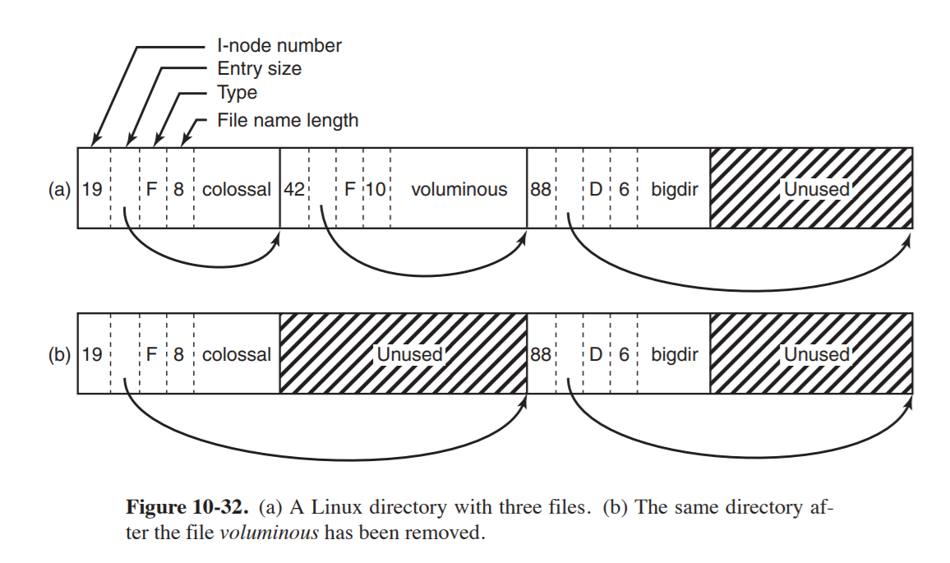

The directory file allows file names up to 255 characters and is illustrated in Fig. 10-32. Each directory consists of some integral number of disk blocks so that directories can be written atomically to the disk. Within a directory, entries for files and directories are in unsorted order, with each entry directly following the one before it. Entries may not span disk blocks, so often there are some number of unused bytes at the end of each disk block. Each directory entry in Fig. 10-32 consists of four fixed-length fields and one variable-length field. The first field is the i-node number, 19 for the file colossal, 42 for the file voluminous, and 88 for the directory bigdir. Next comes a field rec len, telling how big the entry is (in bytes), possibly including some padding after the name. This field is needed to find the next entry for the case that the file name is padded by an unknown length. That is the meaning of the arrow in Fig. 10-32. Then comes the type field: file, directory, and so on. The last fixed field is the length of the actual file name in bytes, 8, 10, and 6 in this example. Finally, comes the file name itself, terminated by a 0 byte and padded out to a 32-bit boundary. Additional padding may follow that

In Fig. 10-32(b) we see the same directory after the entry for voluminous has been removed. All the removeal has done is increase the size of the total entry field for colossal, turning the former field for voluminous into padding for the first entry. This padding can be used for a subsequent entry, of course.

Wpis katalogu nie zawiera metadanych pliku – gdzie w takim razie są one składowane?
It's not stored in that file. It's stored in the filesystem, and all parameters are copied manually one-by-one (though some cannot be copied at all).

In the context of Unix or Linux file systems, "metadata" is information about a file: user ID of who owns it, permissions, file type (special, regular, named pipe, etc) and which disk-blocks the file uses.

In the case of the *nix file system, the metadata used by fsck from a header on each data block points back to a directory entry or the next block of data and the corresponding entries in the directory. fsck scans the blocks and checks that the directory entries match and that forward pointers to the next block are correct.
This varies greatly between file systems. In fact what metadata is stored and where it is stored is what most differentiates the various *nix file systems. The more modern ones also keep a log file of changes to the directory structures.

Co wyraża pole «st_link» struktury «statbuf» opisanej w stat(2)?
st_nlink - This field contains the number of hard links to the file.
A hard link is a directory entry that associates a name with a file (or physical data) on the file system. Hard links allow multiple names to be associated with the same data (and associated inode) from within or outside of a directory. Every time a hard link is created, a directory entry is created and the inode (associated with the directory entry) remains the same across all hard links associated with that data. That is, all names associated with the data point to the same inode.
https://mapr.com/docs/52/AdministratorGuide/Hardlinks.html

Kiedy plik zostaje faktycznie usunięty z dysku?
rm tak naprawdę robi unlink() - just takes the name of the file to be removed, and returns zero upon success

The reason this works is because when the file system unlinks file, it checks a reference count within the inode number. This reference count (sometimes called the link count) allows the file system to track how many different file names have been linked to this particular inode. When unlink() is called, it removes the “link” between the human-readable name (the file that is being deleted) to the given inode number, and decrements the reference count; only when the reference count reaches zero does the file system also free the inode and related data blocks, and thus truly “delete” the file. You can see the reference count of a file using stat() of course. Let’s see what it is when we create and delete hard links to a file. In this example, we’ll create three links to the same file, and then delete them. Watch the link count!

strona 19 file-intro

Zadanie 4 (P).
Jaką rolę pełnią bity uprawnień «rwx» dla katalogów w systemach uniksowych? Opisz znaczenie bitów «set-uid», «set-gid» i «sticky» dla katalogów. Zaprezentuj pseudokod procedury «bool my_access(struct stat *statbuf, int mode)». Pierwszy argument opisano w stat(2), a drugi w access(2). Dla procesu o tożsamości zadanej przez getuid(2) i getgroups(2) procedura «my_access» odpowiada czy proces ma dostęp «mode» do pliku o metadanych wczytanych do «statbuf».

Jaką rolę pełnią bity uprawnień «rwx» dla katalogów w systemach uniksowych?

directory = list of names.
Read bit = If set, you can read this list. So, for example, if you have a directory named poems:
- You can ls poems and you'll get a list of items living within (-l won't reveal any details!).
- You can use command-line completion i.e. touch poems/so <TAB> poems/somefile.
- You cannot make poems your working directory (i.e. cd into it).
Write bit = If set, you can modify this list i.e. you can {add,rename,delete} names on it. But! You can actually do it only if the execute bit is set too.
Execute bit = Make this directory your working directory i.e. cd into it. You need this permission if you want to:
- access (read, write, execute) items living within.
- modify the list itself i.e. add, rename, delete names on it (of course the write bit must be set on the directory).
Interesting case 1: If you have write + execute permissions on a directory, you can {delete,rename} items living within even if you don't have write permission on those items. (use sticky bit to prevent this)
Interesting case 2: If you have execute (but not write) permission on a directory AND you have write permission on a file living within, you cannot delete the file (because it involves removing it from the list). However, you can erase its contents e.g. if it's a text file you can use vi to open it and delete everything. The file will still be there, but it will be empty.
Summary:
Read bit = You can read the names on the list.
Write bit = You can {add,rename,delete} names on the list IF the execute bit is set too.
Execute bit = You can make this directory your working directory.

Opisz znaczenie bitów «set-uid», «set-gid» i «sticky» dla katalogów.
The setuid bit has no effect on directories.
Setgid bit alters the standard behavior so that the group of the files created inside said directory, will not be that of the user who created them, but that of the parent directory itself. This is often used to ease the sharing of files (files will be modifiable by all the users that are part of said group).
The sticky bit works in a different way: while it has no effect on files, when used on a directory, all the files in said directory will be modifiable only by their owners. A typical case in which it is used, involves the /tmp directory. Typically this directory is writable by all users on the system, so to make impossible for one user to delete the files of another one, the sticky bit is set

Zaprezentuj pseudokod procedury «bool my_access(struct stat *statbuf, int mode)». Pierwszy argument opisano w stat(2), a drugi w access(2). Dla procesu o tożsamości zadanej przez getuid(2) i getgroups(2) procedura «my_access» odpowiada czy proces ma dostęp «mode» do pliku o metadanych wczytanych do «statbuf».
statbuf
struct stat {
dev_t st_dev; /* ID of device containing file */
ino_t st_ino; /* Inode number */
mode_t st_mode; /* File type and mode */
nlink_t st_nlink; /* Number of hard links */
uid_t st_uid; /* User ID of owner */
gid_t st_gid; /* Group ID of owner */
dev_t st_rdev; /* Device ID (if special file) */
off_t st_size; /* Total size, in bytes */
blksize_t st_blksize; /* Block size for filesystem I/O */
blkcnt_t st_blocks; /* Number of 512B blocks allocated */

/* Since Linux 2.6, the kernel supports nanosecond
precision for the following timestamp fields.
For the details before Linux 2.6, see NOTES. */

struct timespec st_atim; /* Time of last access */
struct timespec st_mtim; /* Time of last modification */
struct timespec st_ctim; /* Time of last status change */

#define st_atime st_atim.tv_sec /* Backward compatibility */
#define st_mtime st_mtim.tv_sec
#define st_ctime st_ctim.tv_sec
};
mode
The mode specifies the accessibility check(s) to be performed, and is
either the value F_OK, or a mask consisting of the bitwise OR of one
or more of R_OK, W_OK, and X_OK. F_OK tests for the existence of the
file. R_OK, W_OK, and X_OK test whether the file exists and grants
read, write, and execute permissions, respectively.
